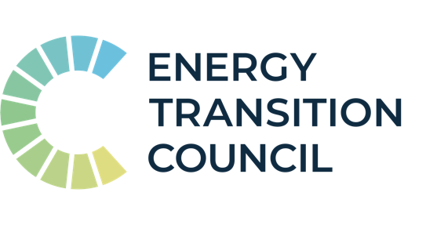

Energy Transition Council

Who we are
Multilateral platform with over 30 governments, multilateral development banks, technical partners and international organisations
20 partner countries with clean energy transition challenges and opportunities
High-trust dialogue mobilising, aligning, and coordinating support for the clean energy transition
Rapid Response Facility (RRF) delivering fast-acting and demand-driven technical assistance to address transition barriers and unlock larger term finance
Collaborating on key areas, including coal retirement, renewables deployment, energy efficiency and a just transition
Dialogues and RRF support set to continue to at least to 2025

What we’ve done so far
14 ETC national dialogues to identify energy transition priorities, shared challenges and sources of international support
6 ETC ministerials to raise confidence in ability to deliver on shared challenges; secure ministerial buy-in to energy transition agenda; and foster senior-level, high-trust dialogue
100s of smaller focused strategy sessions and working groups to address and unblock challenges impeding the energy transition
27 RRF technical requests in energy efficiency, just transition and clean cooking across
9 ETC Countries, with more in the pipeline responded to by over
25 delivery partners, with more in the pipeline
Resulting in significant clean energy commitments made by ETC partner countries, including through the COP26 Global Coal to Clean Power Statement

Partner countries
- Indonesia
- India
- Vietnam
- Philippines
- Laos PDR
- Bangladesh
- Pakistan
- Morocco
- Egypt
- Nigeria
- Kenya

Donor governments
- France
- Germany
- European Commission
- Denmark
- US
- Canada
- Netherlands
- Norway
- Sweden

Institutions & philanthropies
African Development Bank, Asian Development Bank, Bloomberg Philanthropies, Climate Emergency Collaboration Group, Climate Investment Funds, Coal Asset Transition Accelerator, European Bank for Reconstruction and Development, European Climate Fund, European Investment Bank, Global Energy Alliance for People and Planet, Green Climate Fund, International Energy Agency, International Finance Corporation, International Labour Organisation, International Network of Energy Transition Think Tanks, International Renewable Energy Agency, International Solar Alliance, Quadrature Climate Fund, Rockefeller Foundation, South-East Asia Energy Transition Partnership, World Bank, and over 25 RRF delivery partners.

